Use-Case Realization Report
Update Lesson

Issue <1.0>
Revision History
Date | Issue | Description | Author
<dd/mmm/yy> | <x.x> | <details> | <name>

Table of Contents
1. Brief Description 4
2. Flow of Events 4
3. Interaction Diagrams 4
3.1 Collaboration Diagram for Update Lesson 4
4. Participating Objects 4
5. Class Diagrams 5
5.1 Class Diagram for Update Lesson 5
6. Derived Requirements 6

Use-Case Realization Report
Update Lesson

Brief Description

Flow of Events

Standard Flow
- Portal Admin clicks the “Update” button.
- Lesson controller will call Lesson Page to display itself.
- Portal Admin update the lesson content via Lesson Page.
- Lesson and relevant lesson sections will be updated.
- Lesson module will then be updated and marked the updated lesson.

Interaction Diagrams

Collaboration Diagram for Update Lesson
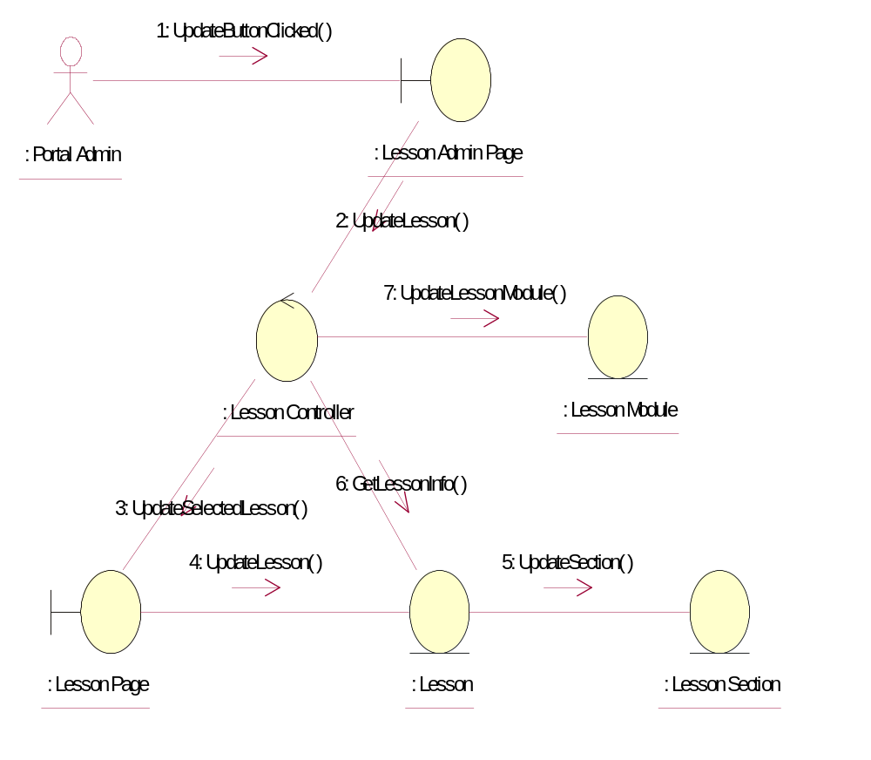

Participating Objects
: Lesson
This entity is the lesson object, it belongs to JMD.
: Lesson Admin Page
This is the page for adding, deleting, modifying lessons.
: Lesson Controller
This is the controller to upload, add, delete and modify lessons.
: Lesson Module
This is the object containing the lesson info.
: Lesson Page
Lesson Page is the one from JMD, which in charge of creating lessons.
: Lesson Section
This entity is the Section object, it belongs to JMD.
: Portal Admin
This is the super user of the system.

Class Diagrams

Class Diagram for Update Lesson
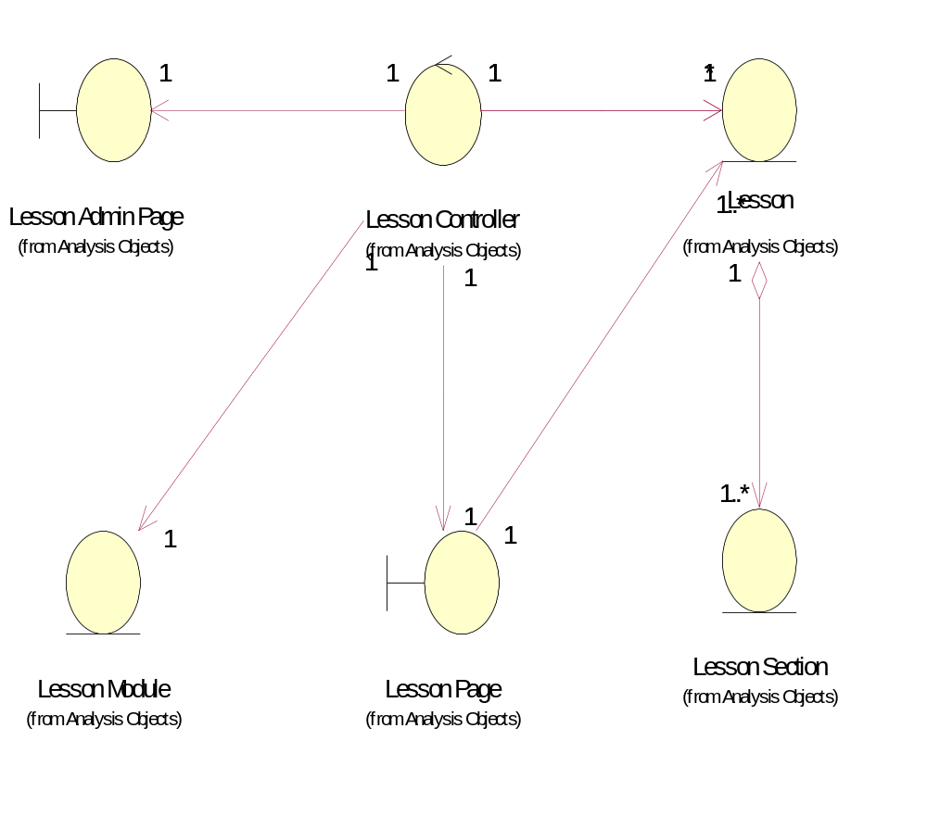

Derived Requirements
[enter the derived requirements here]

